Keras 每个epoch保存模型方法checkpoint

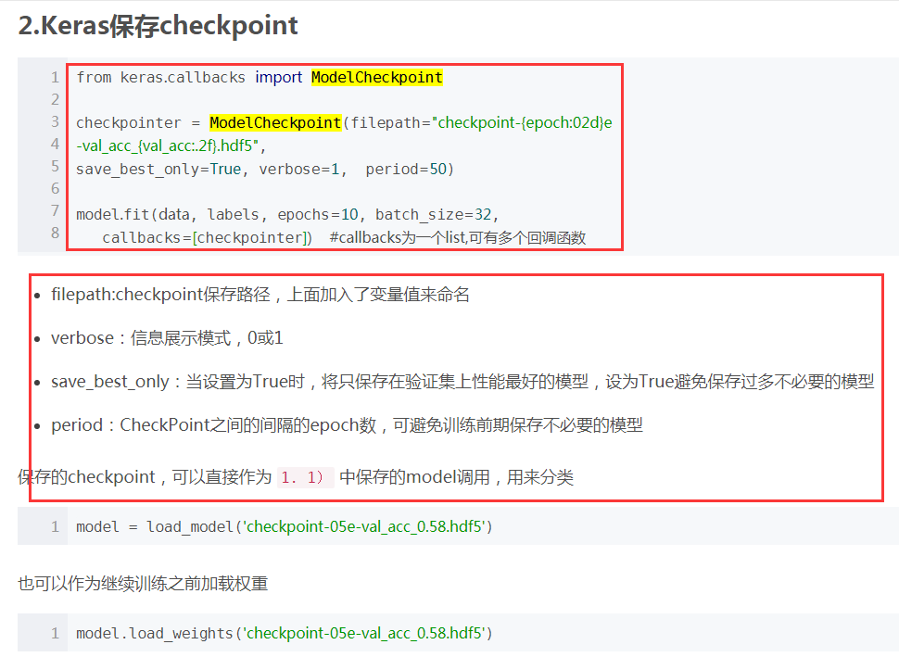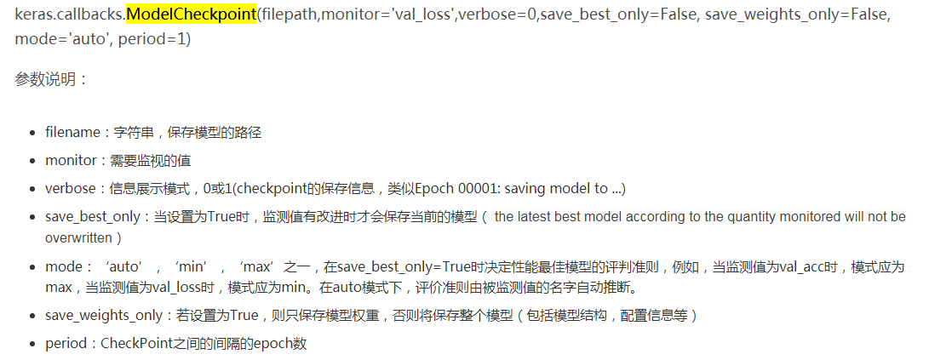
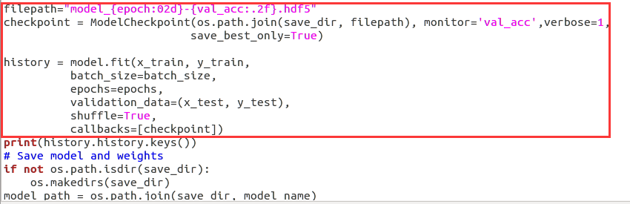

$scp -r ./recsend/cifar10_checkpoint_keras/ sunfengzhen@148.70.23.92:/home/sunfengzhen/sun/
cod: sunfz123456

$ nohup python cifar10_checkpoint.py >out.log &

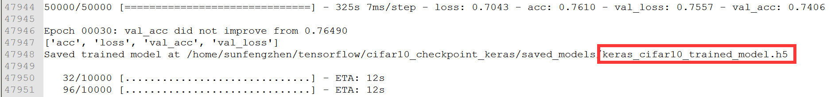
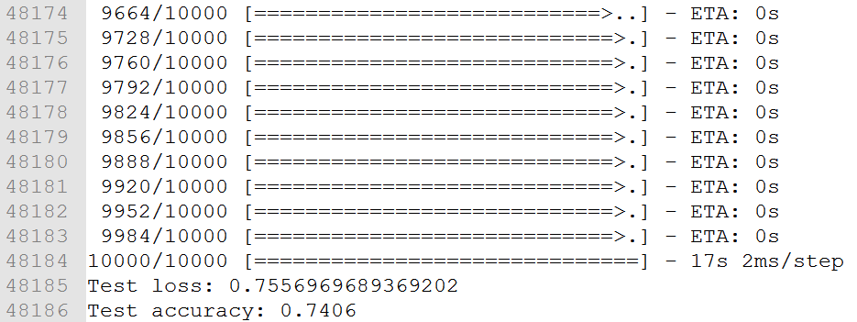
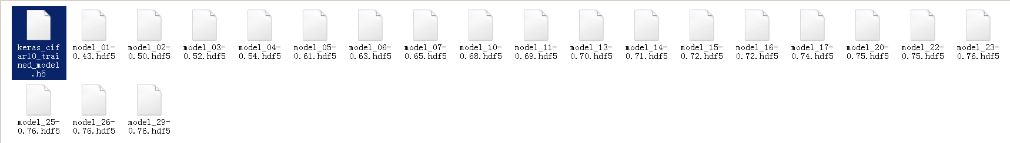
Epoch监控参数val_acc没有改进，不保存模型

参考：
https://blog.csdn.net/breeze5428/article/details/80875323
https://blog.csdn.net/huanghenghua/article/details/80257584

